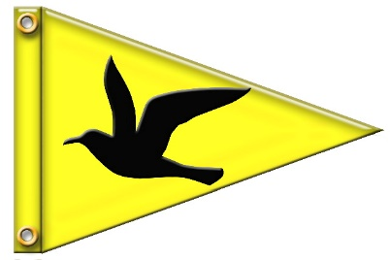

West River Yacht Club Annual Crab Feast
When: Saturday, September 21, 2019
Start time: 1:00 pm (Happy Hour--Drinks & Light Appetizers)
Buffet will start at 2:00 pm
**Live Music by Off the Hook starting at 2pm**

Menu includes:
Steamed Crabs, Maryland Crab Soup,
Baked Ziti with Garlic Bread, Sweet and Sour Meatballs,
Pasta Salad, Tossed Garden Salad,
Corn on the Cob, Sliced Watermelon & Desert
Draft Beer, Wine, Select Mixed Drinks, Water & Soda

Guest Cost

Adults: $60
Children (Ages 6-15): $20
Children 5 and under are Free

PLEASE RSVP By No Later Than Monday, September 10th

